Chariho Regional School District
Office of the Director of Administration & Finance

455A Switch Road
Wood River Junction, Rhode Island 02894

All Kids. All of the Time.

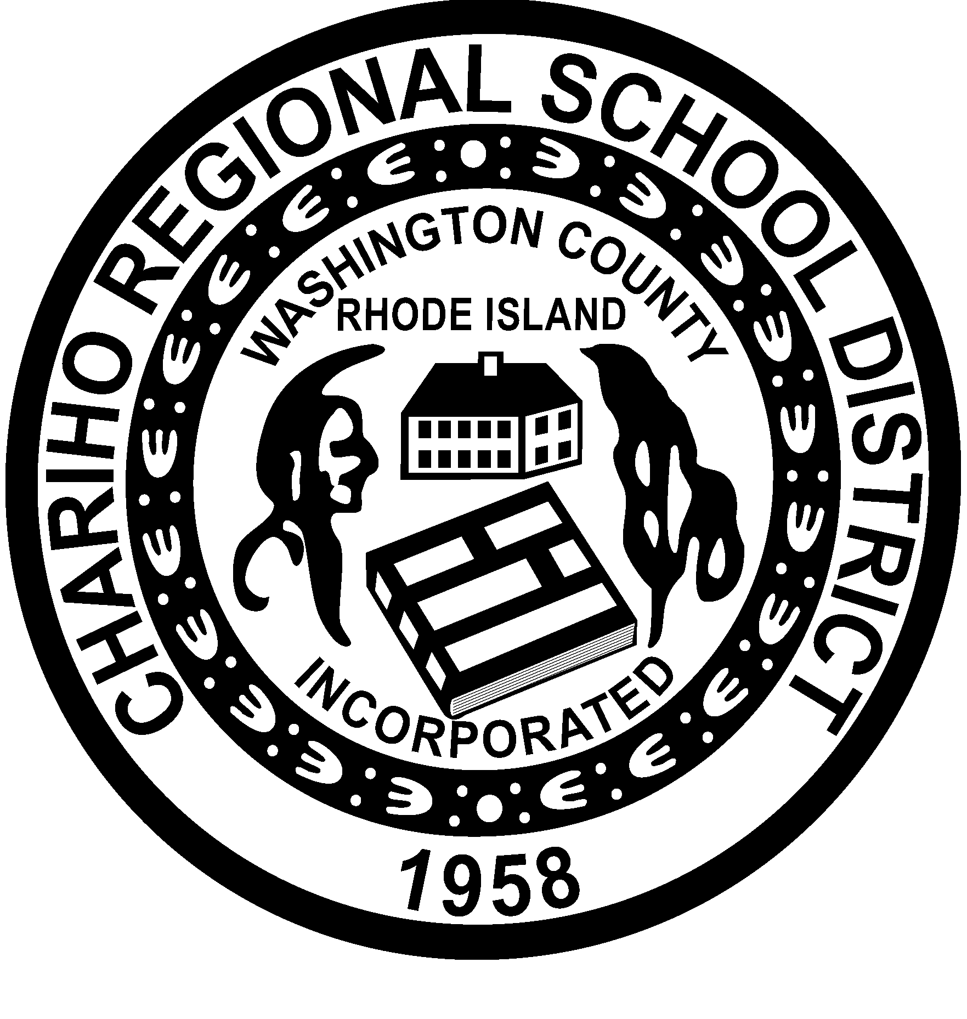

Edward DRAPER
Director of Administration & Finance

Gail e. wilcox
Asst. Director of Administration & Finance

Linda D. Lyall
School Committee Chairperson

Gina M. Picard
Superintendent of Schools

The Chariho Regional School District does not discriminate on the basis of age, sex, marital status, race, religion, genetic information, national origin, color, political affiliation, veteran status, sexual orientation, gender identity or expression, or disability in accordance with applicable law.

Telephone: (401) 364-3260 Fax: (401) 415-6076 Voice/TDD: (401) 364-1171
To: Gina Picard
From: Ned Draper
Date: June 10, 2021
Subject: GZA update – Chariho Middle School Oil Spill monitoring report for operations April 2020 – April 2021, June 2021 File No. 03.0033632.02

Per memo of School Committee meeting in November a review of the GZA spill monitoring activity of the prior year was provided to my office by GZA in January as a draft for review by GZA representatives John Spirito and Al Flori. This report was updated in April to include spring monitor results when the water table provides best levels for testing. The following information is in the report:
  - Routine inspection and maintenance operations through April 2021
  - Historical data and results of remediation efforts to date over the past decade and anticipated outcomes for the current year
  - This is the final report for School Committee review per RIDEM requirements.

Please let me know if there are any questions or concerns.

Thank you.

